The National Environmental Policy Act (NEPA)

Local Public Agency Guide to

Getting through NEPA

**Presented by:**

**Nick Hines, CEP**

NEPA Management and Project

Delivery Supervisor

(307) 777-4156

[Nick.hines@wyo.gov](mailto:Nick.hines@wyo.gov)

**For Cultural Questions Contact:**

Jason Bogstie

Senior Cultural Resources Specialist

(307) 777-4220

[Jason.bogstie@wyo.gov](mailto:Jason.bogstie@wyo.gov)

*(When corresponding with Jason, please cc Nick as well.)*

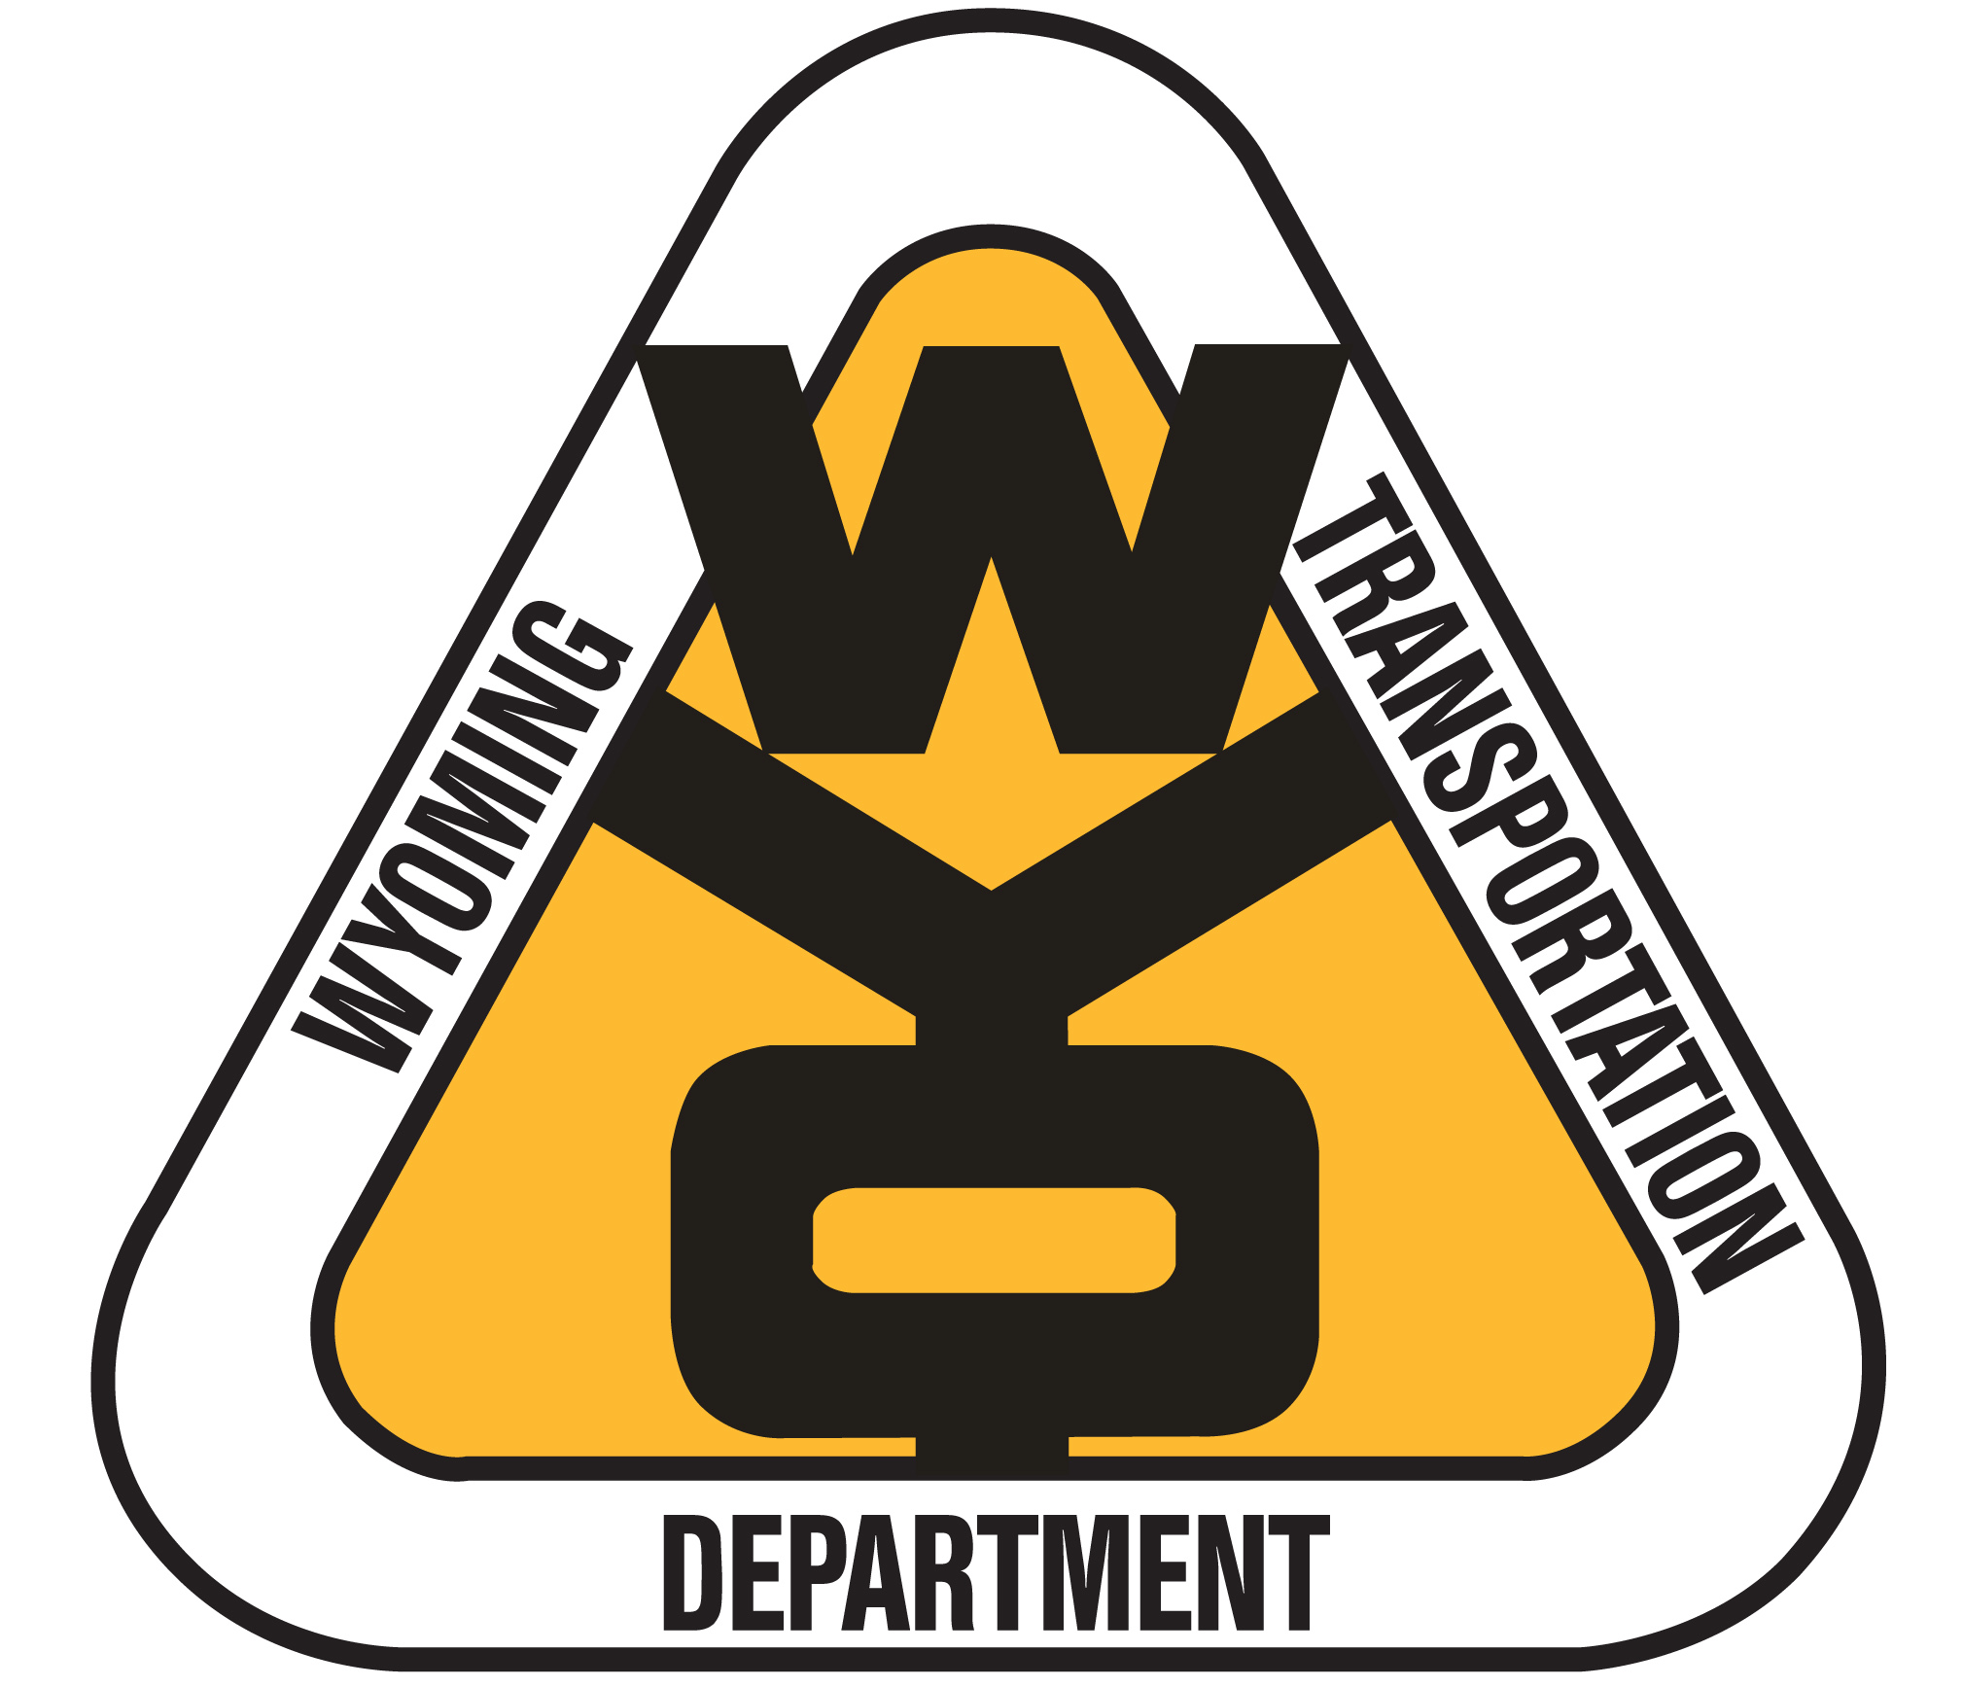

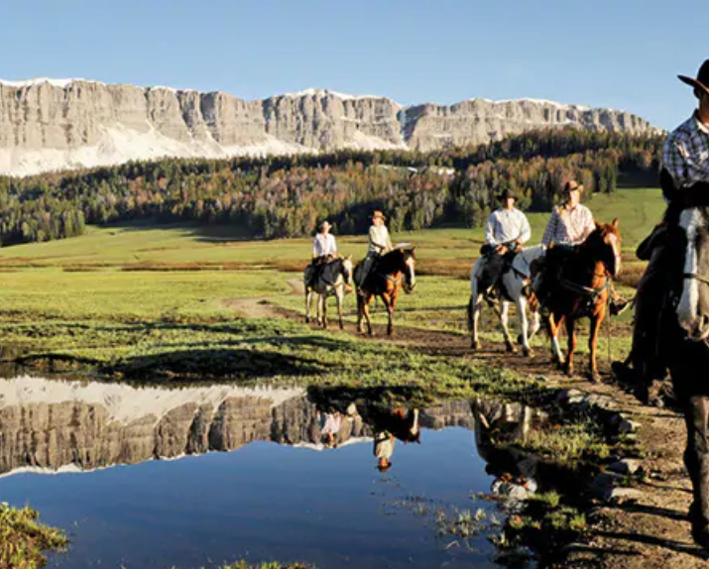(

**My Notes:**

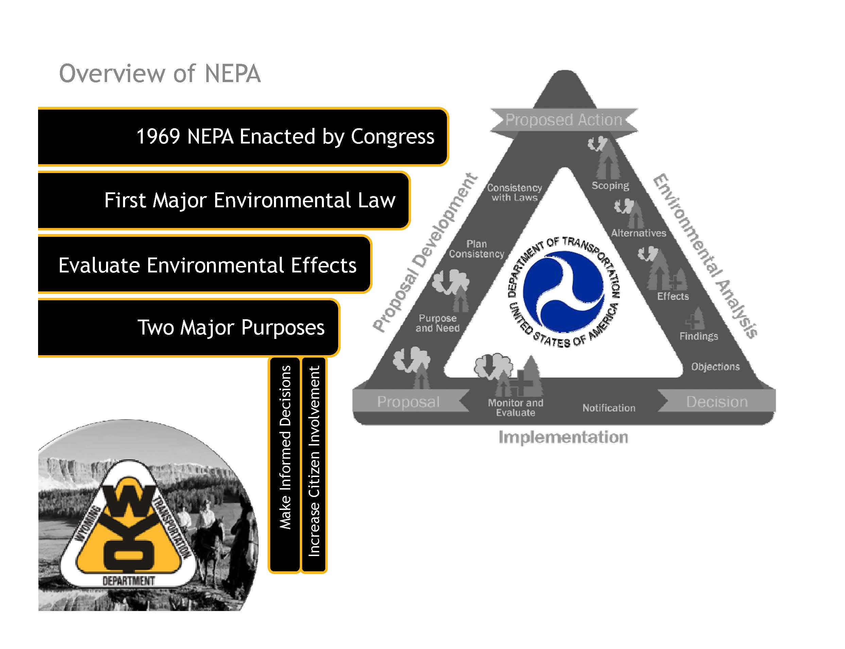

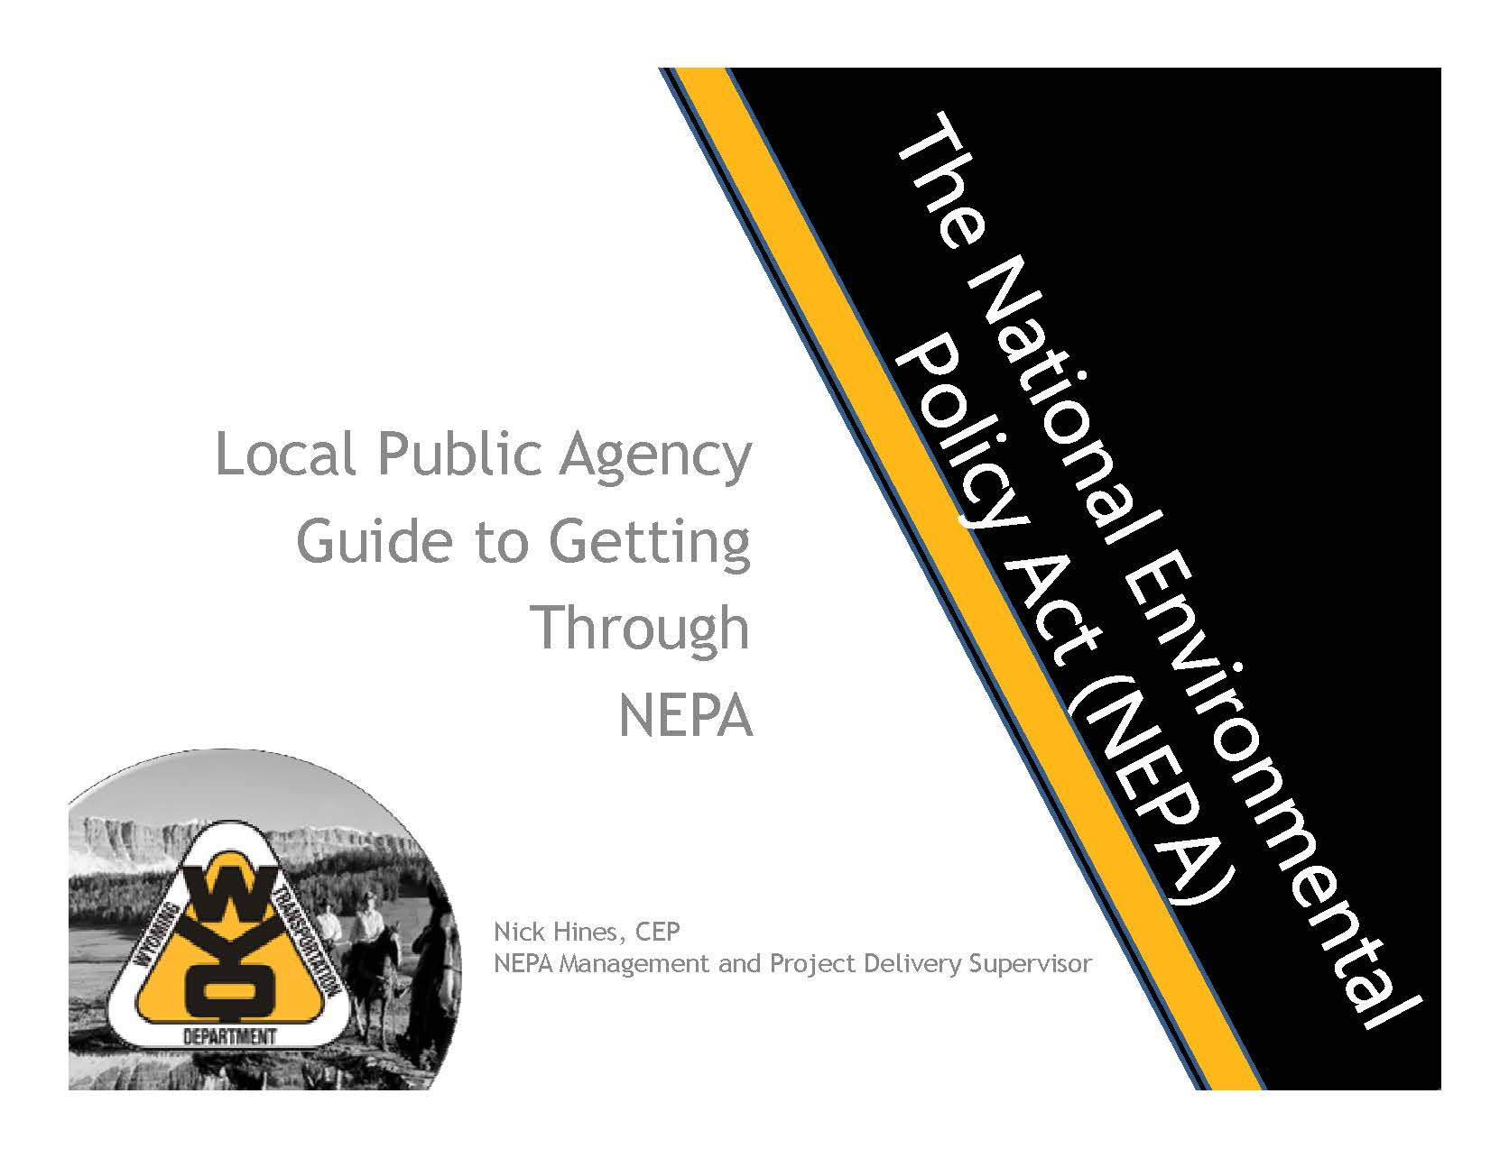

**My Notes:**

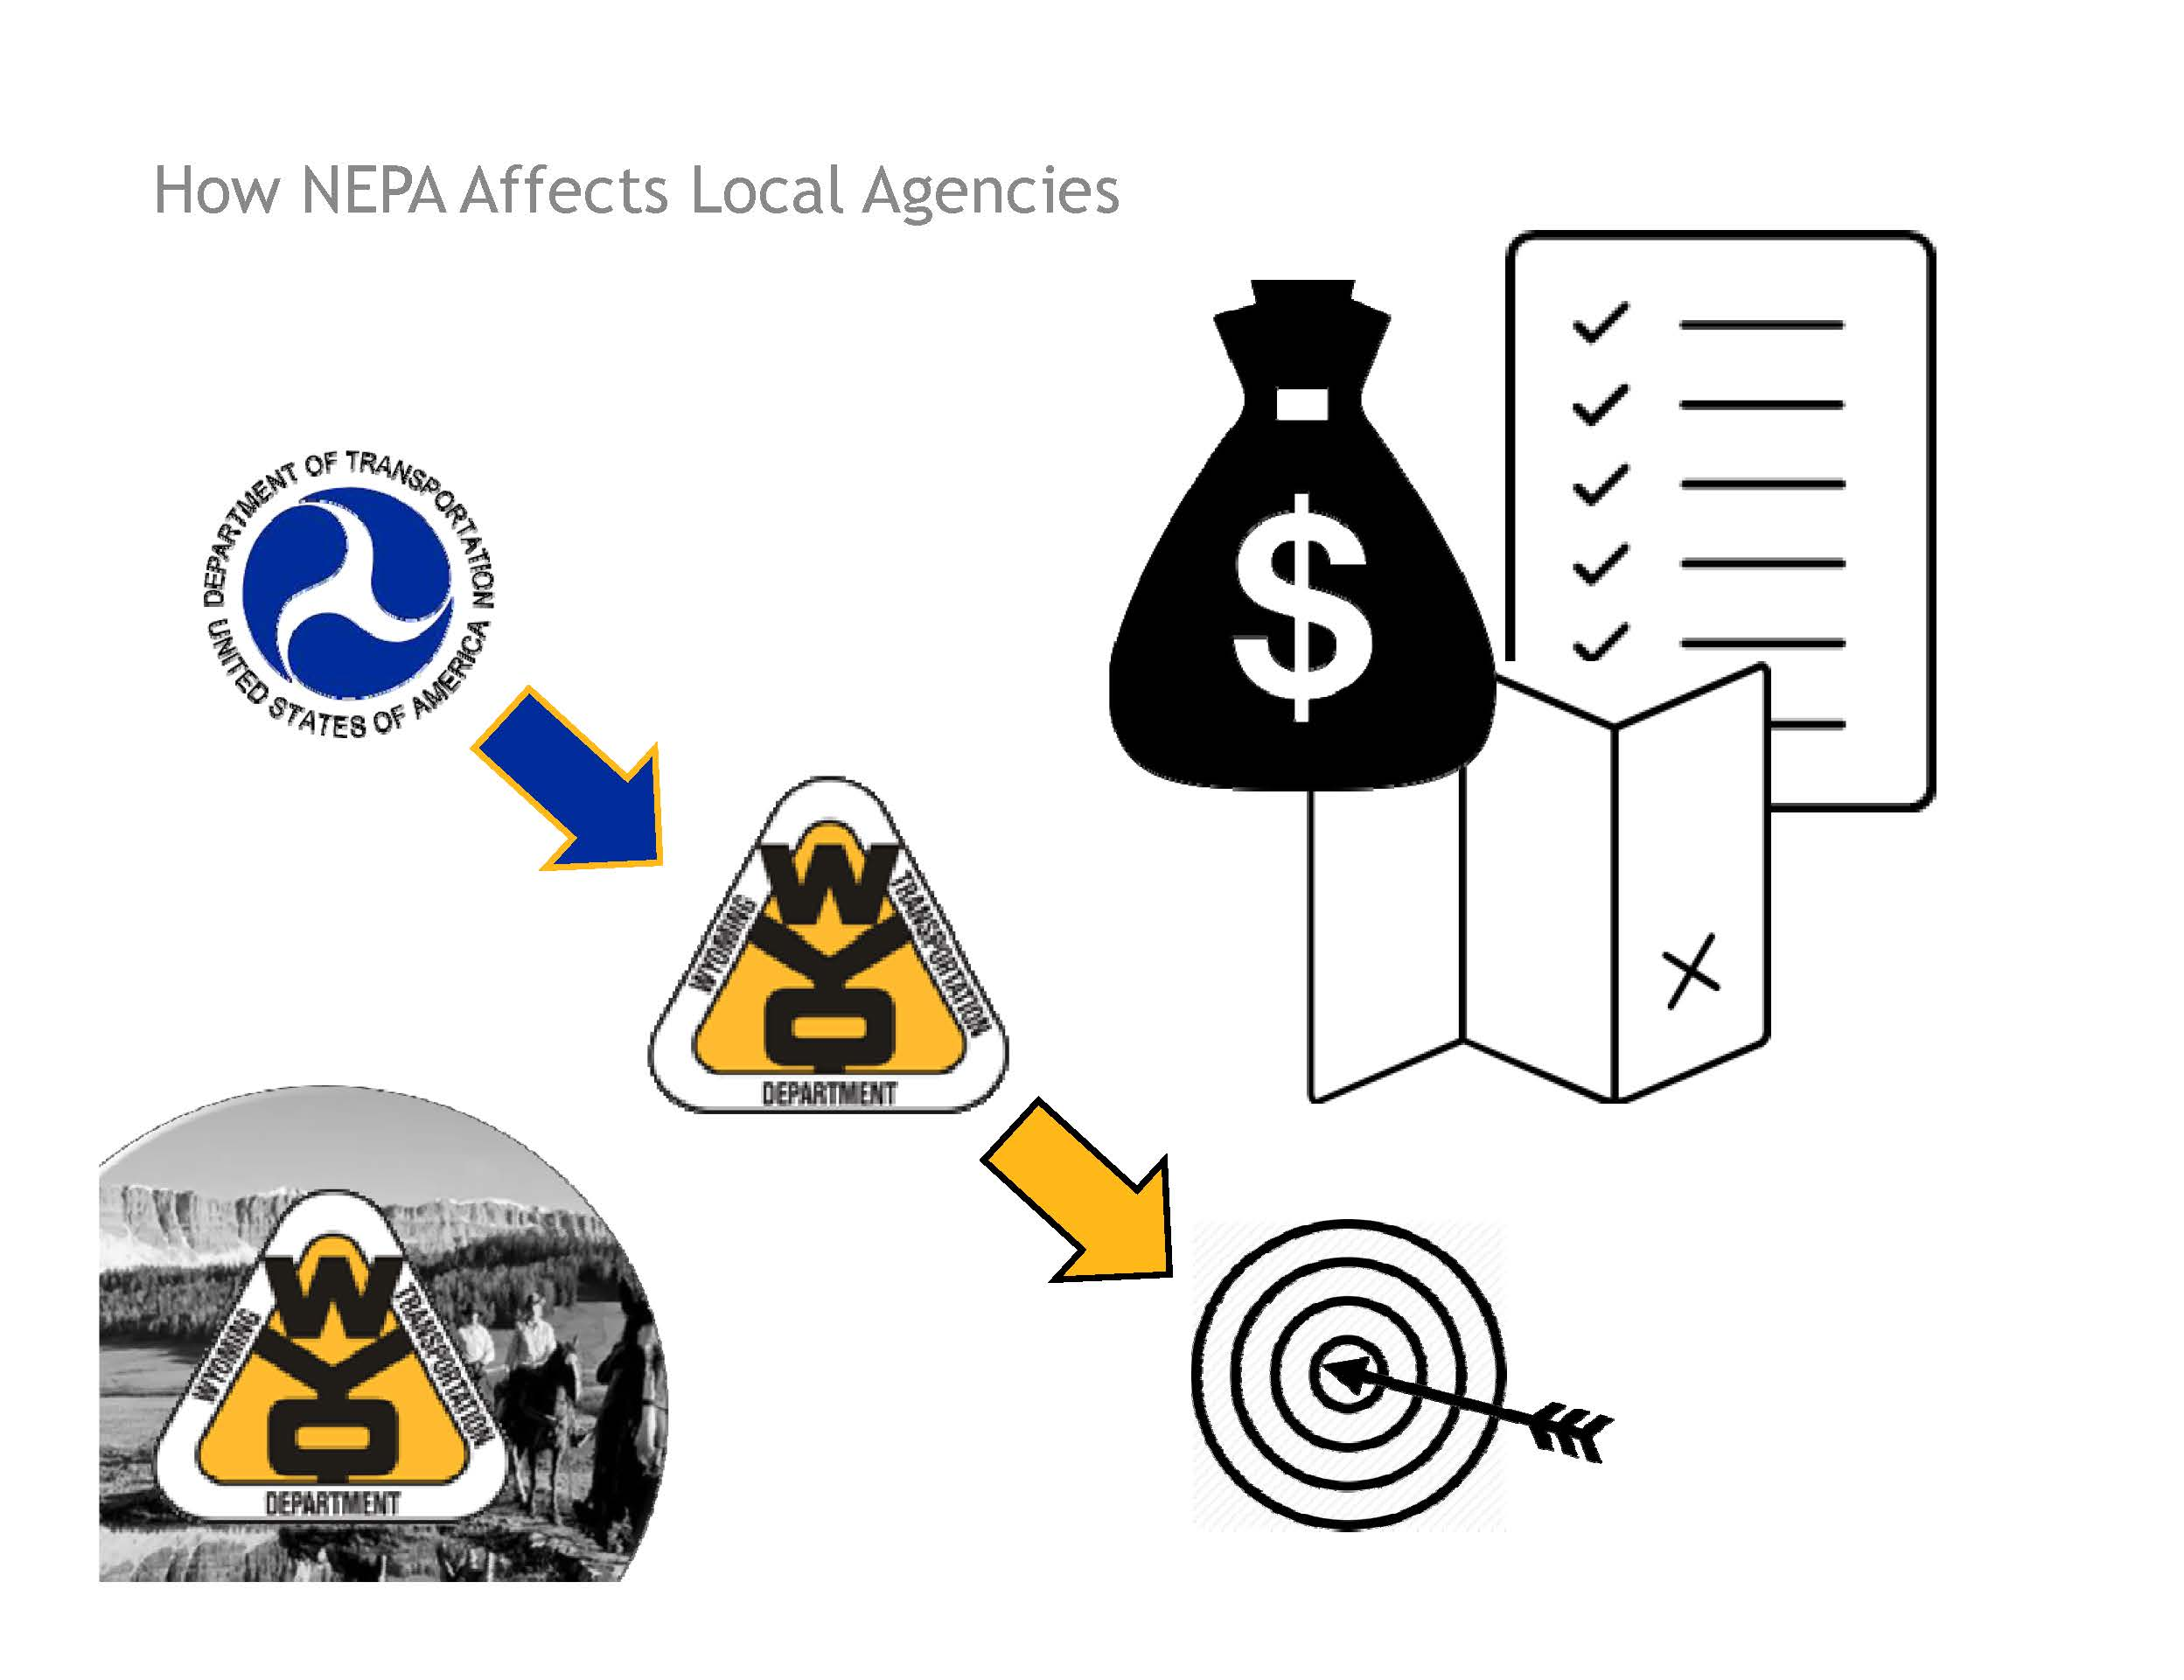

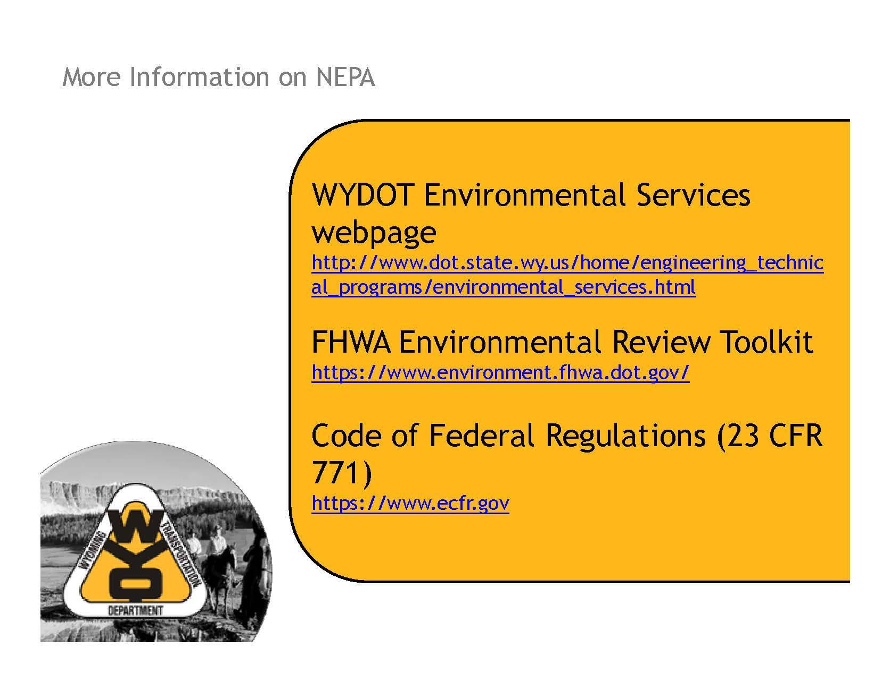

**My Notes:**

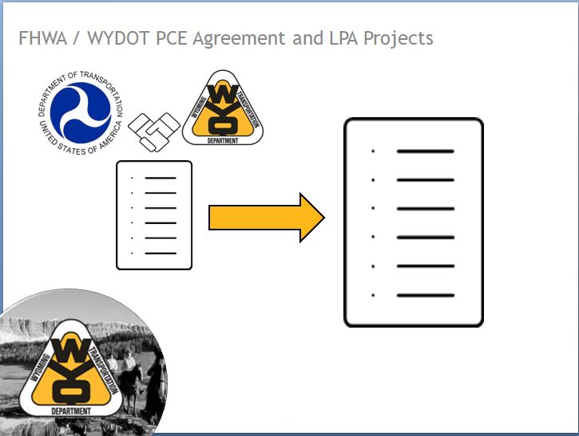

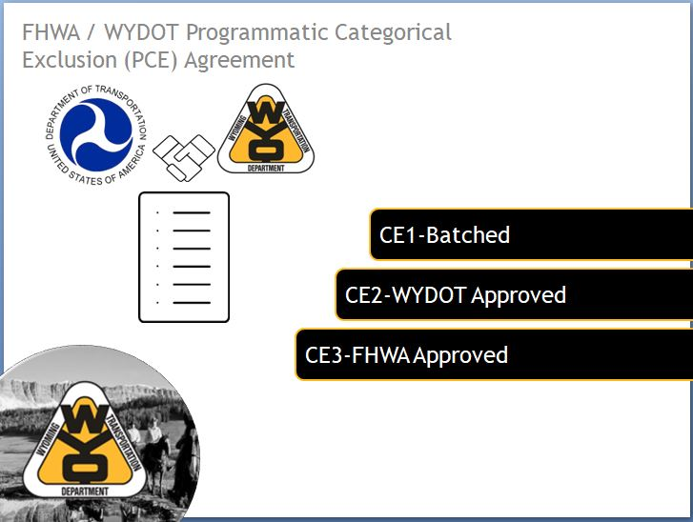

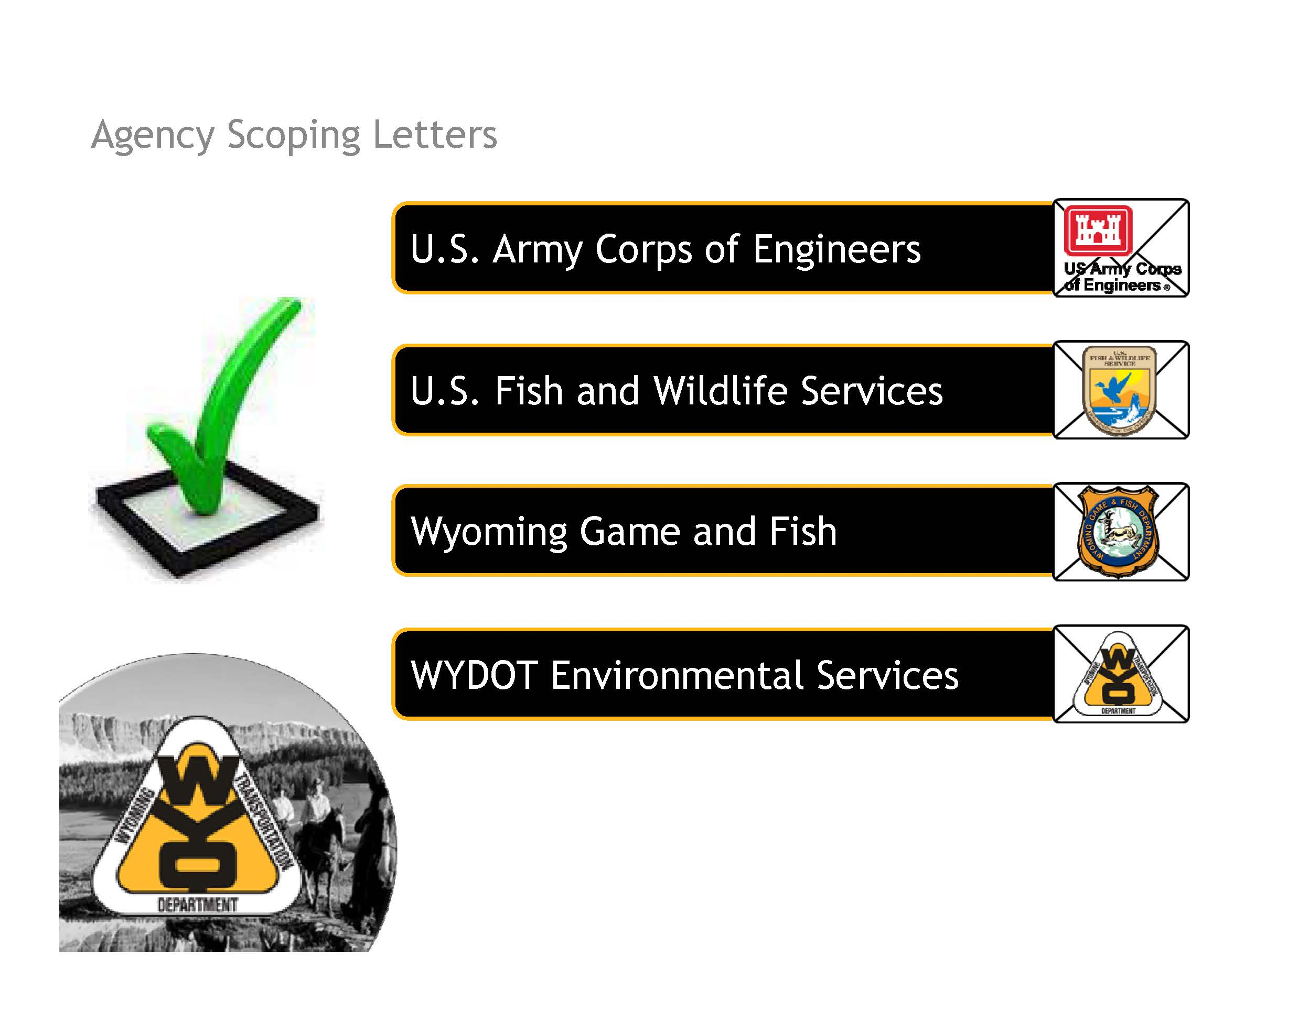

**My Notes:**

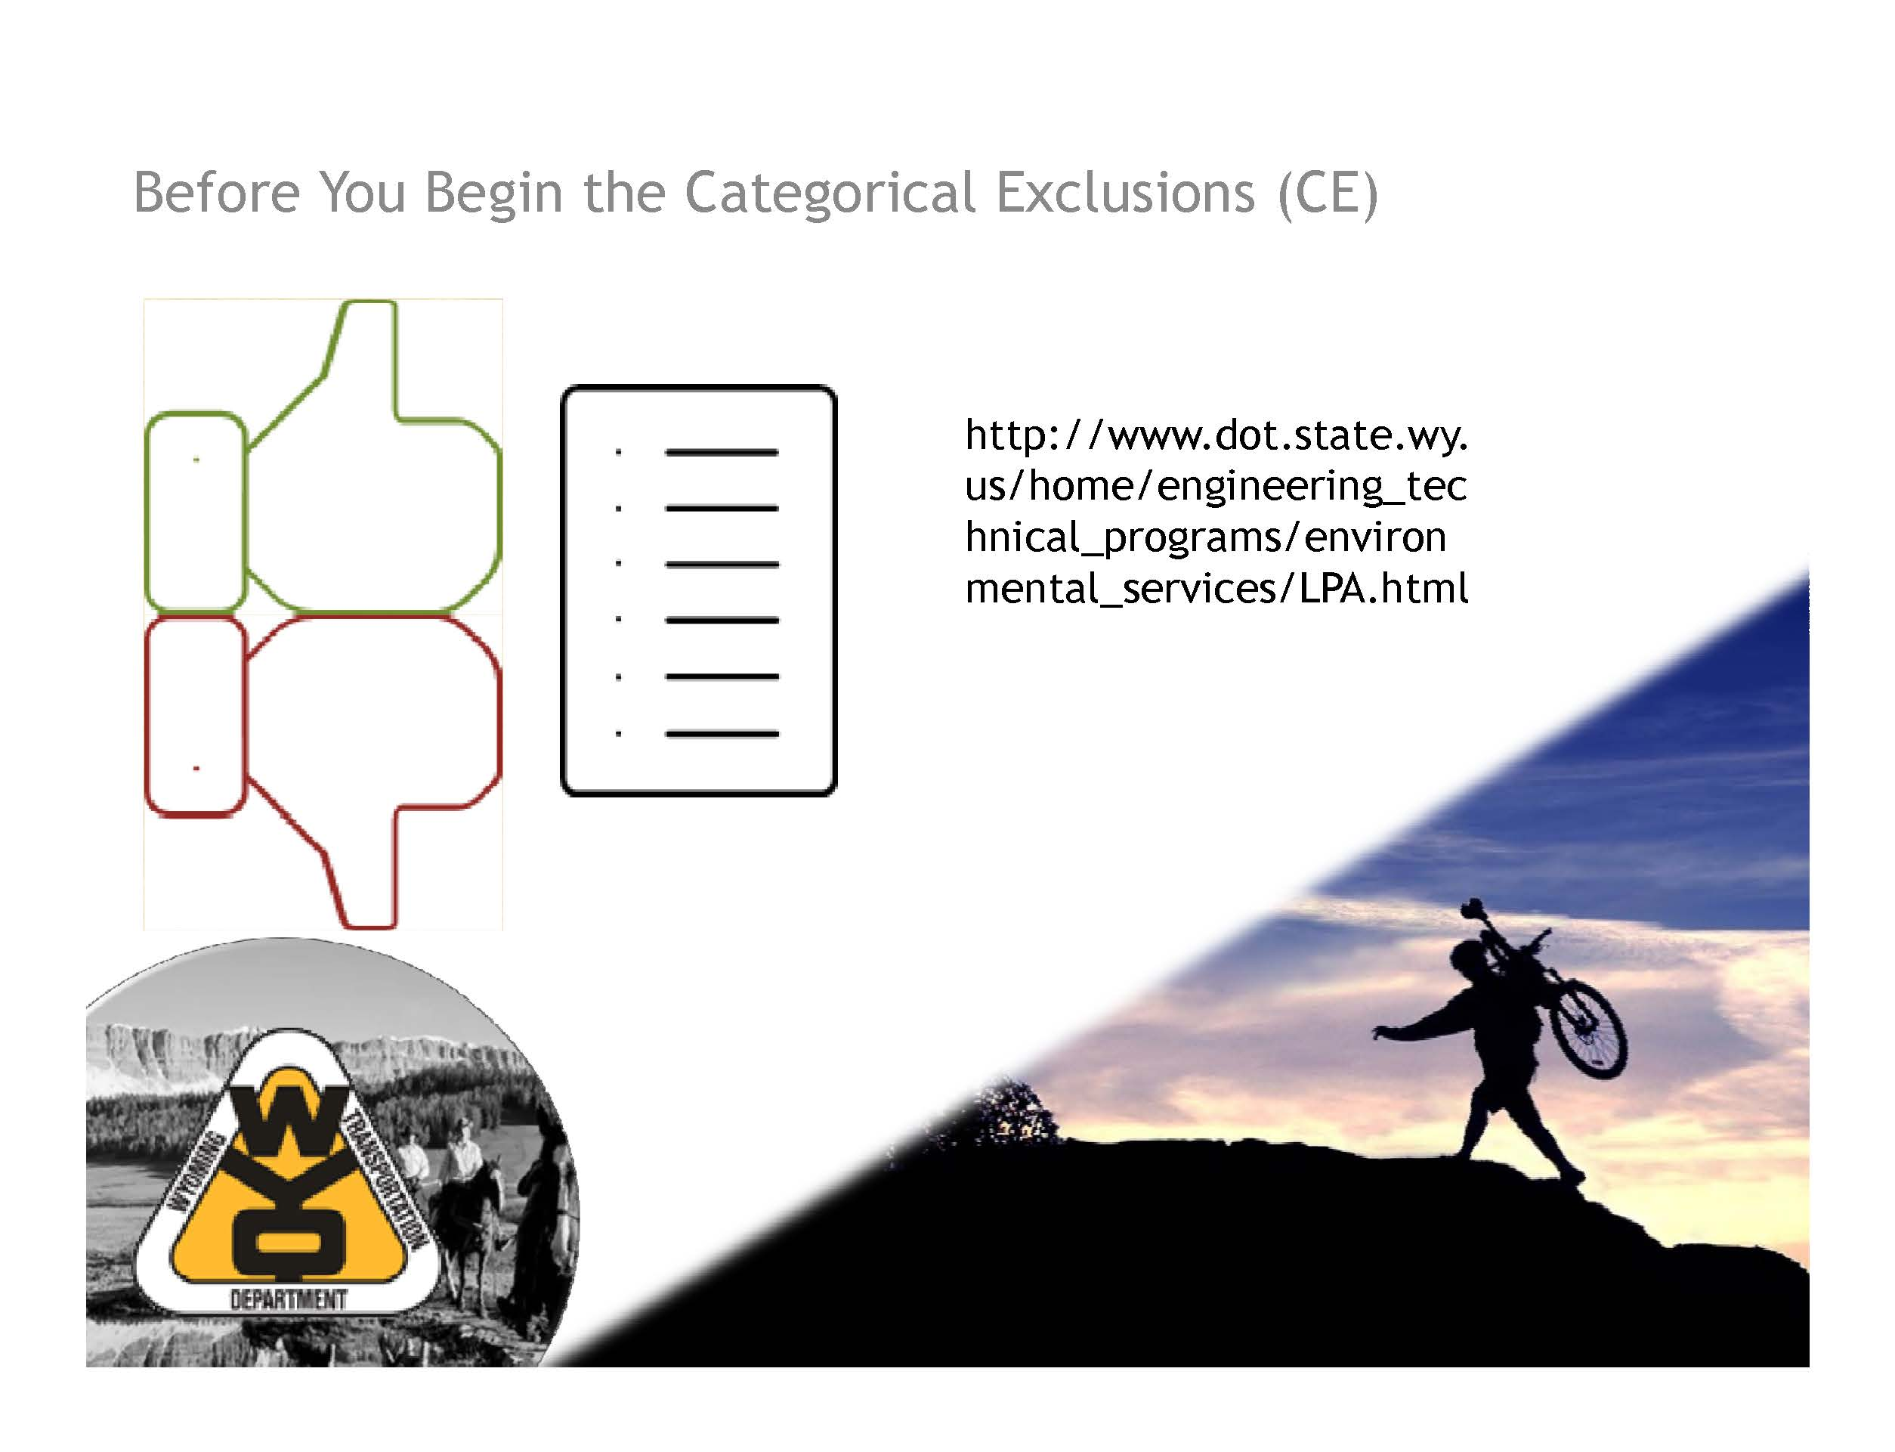

**My Notes:**

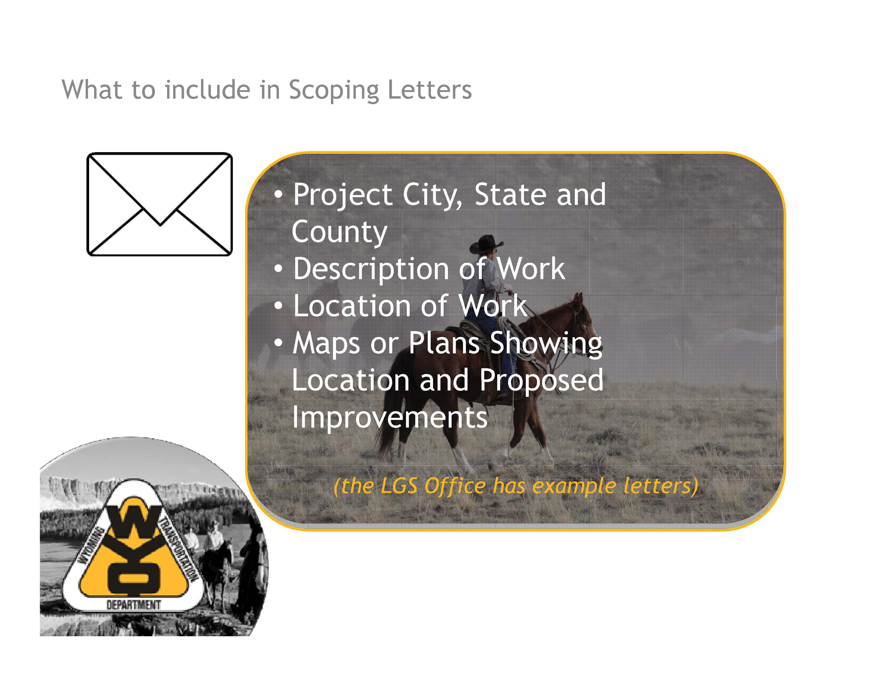

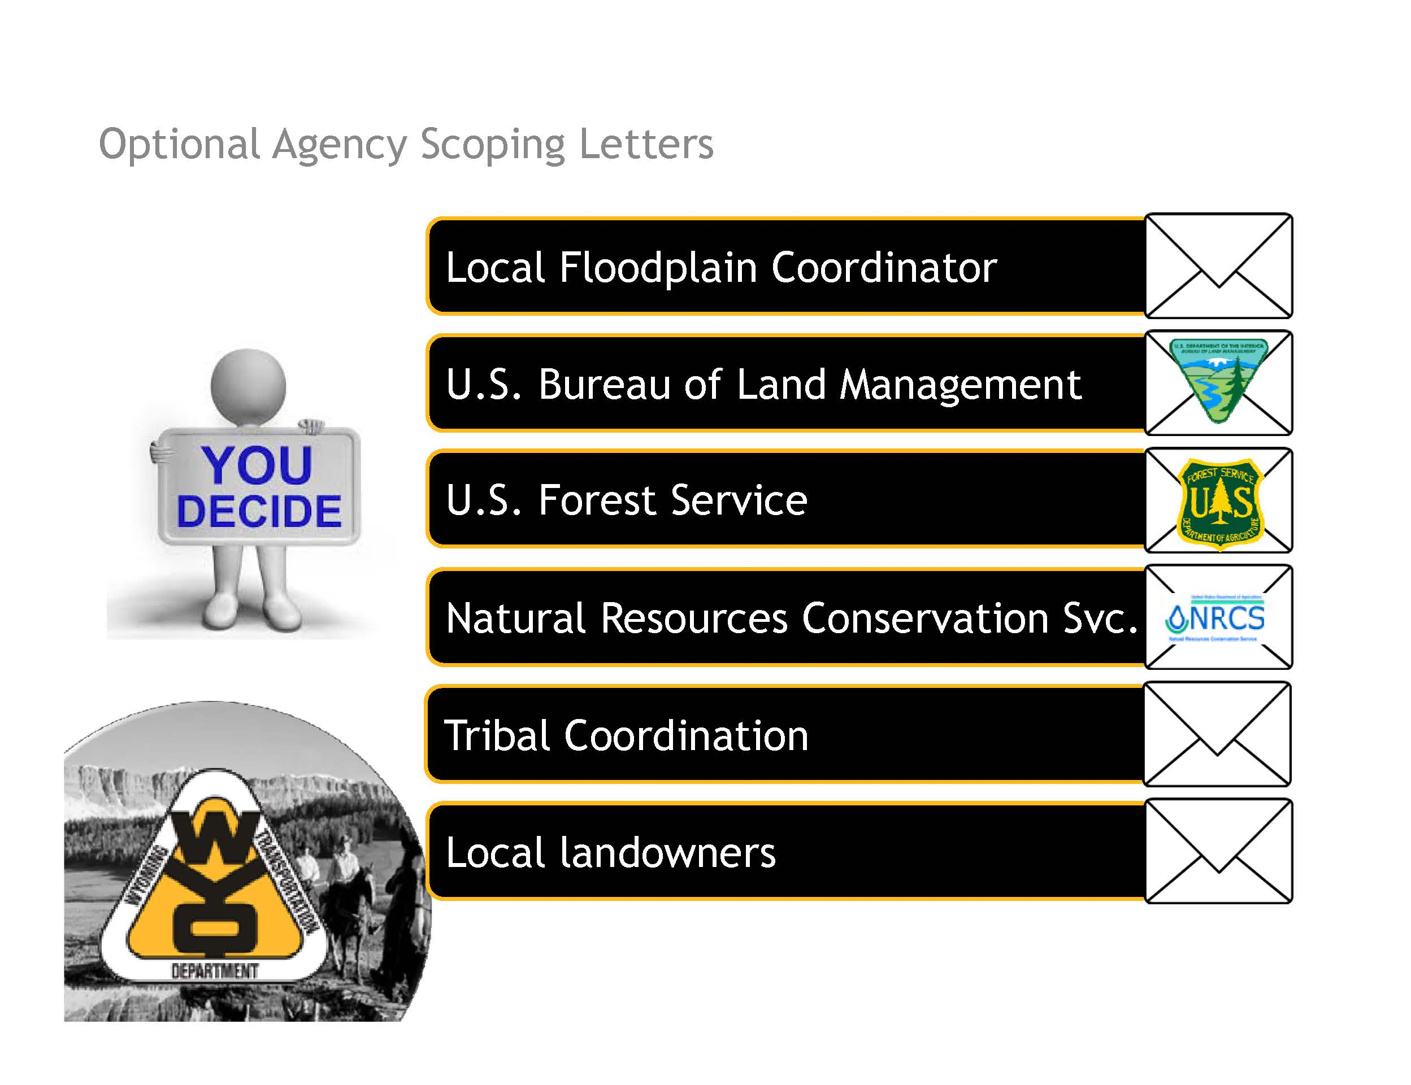

**My Notes:**

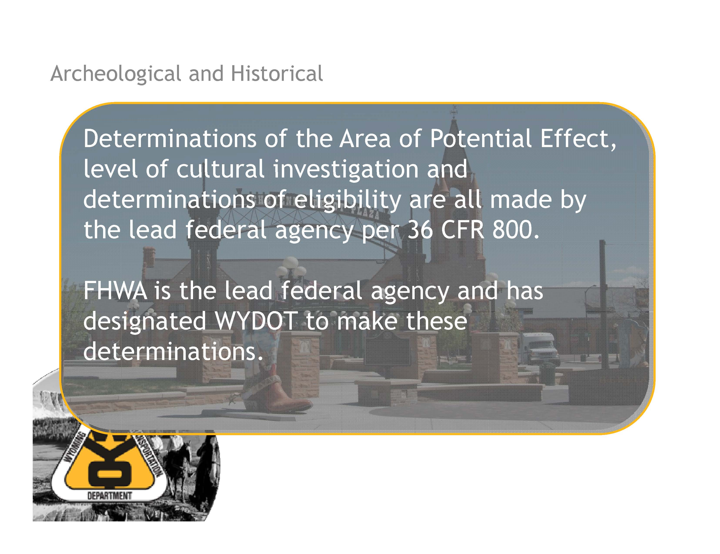

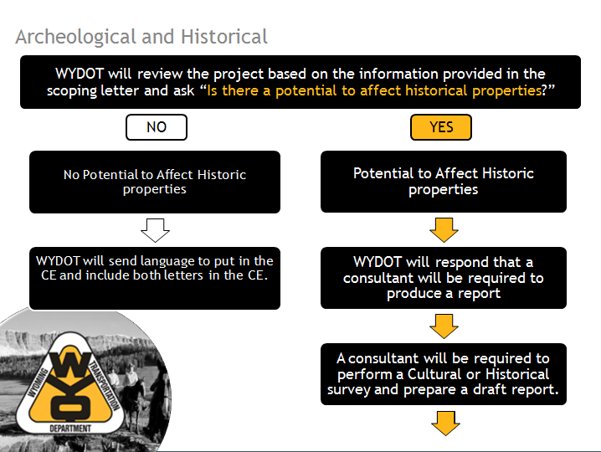

**My Notes:**

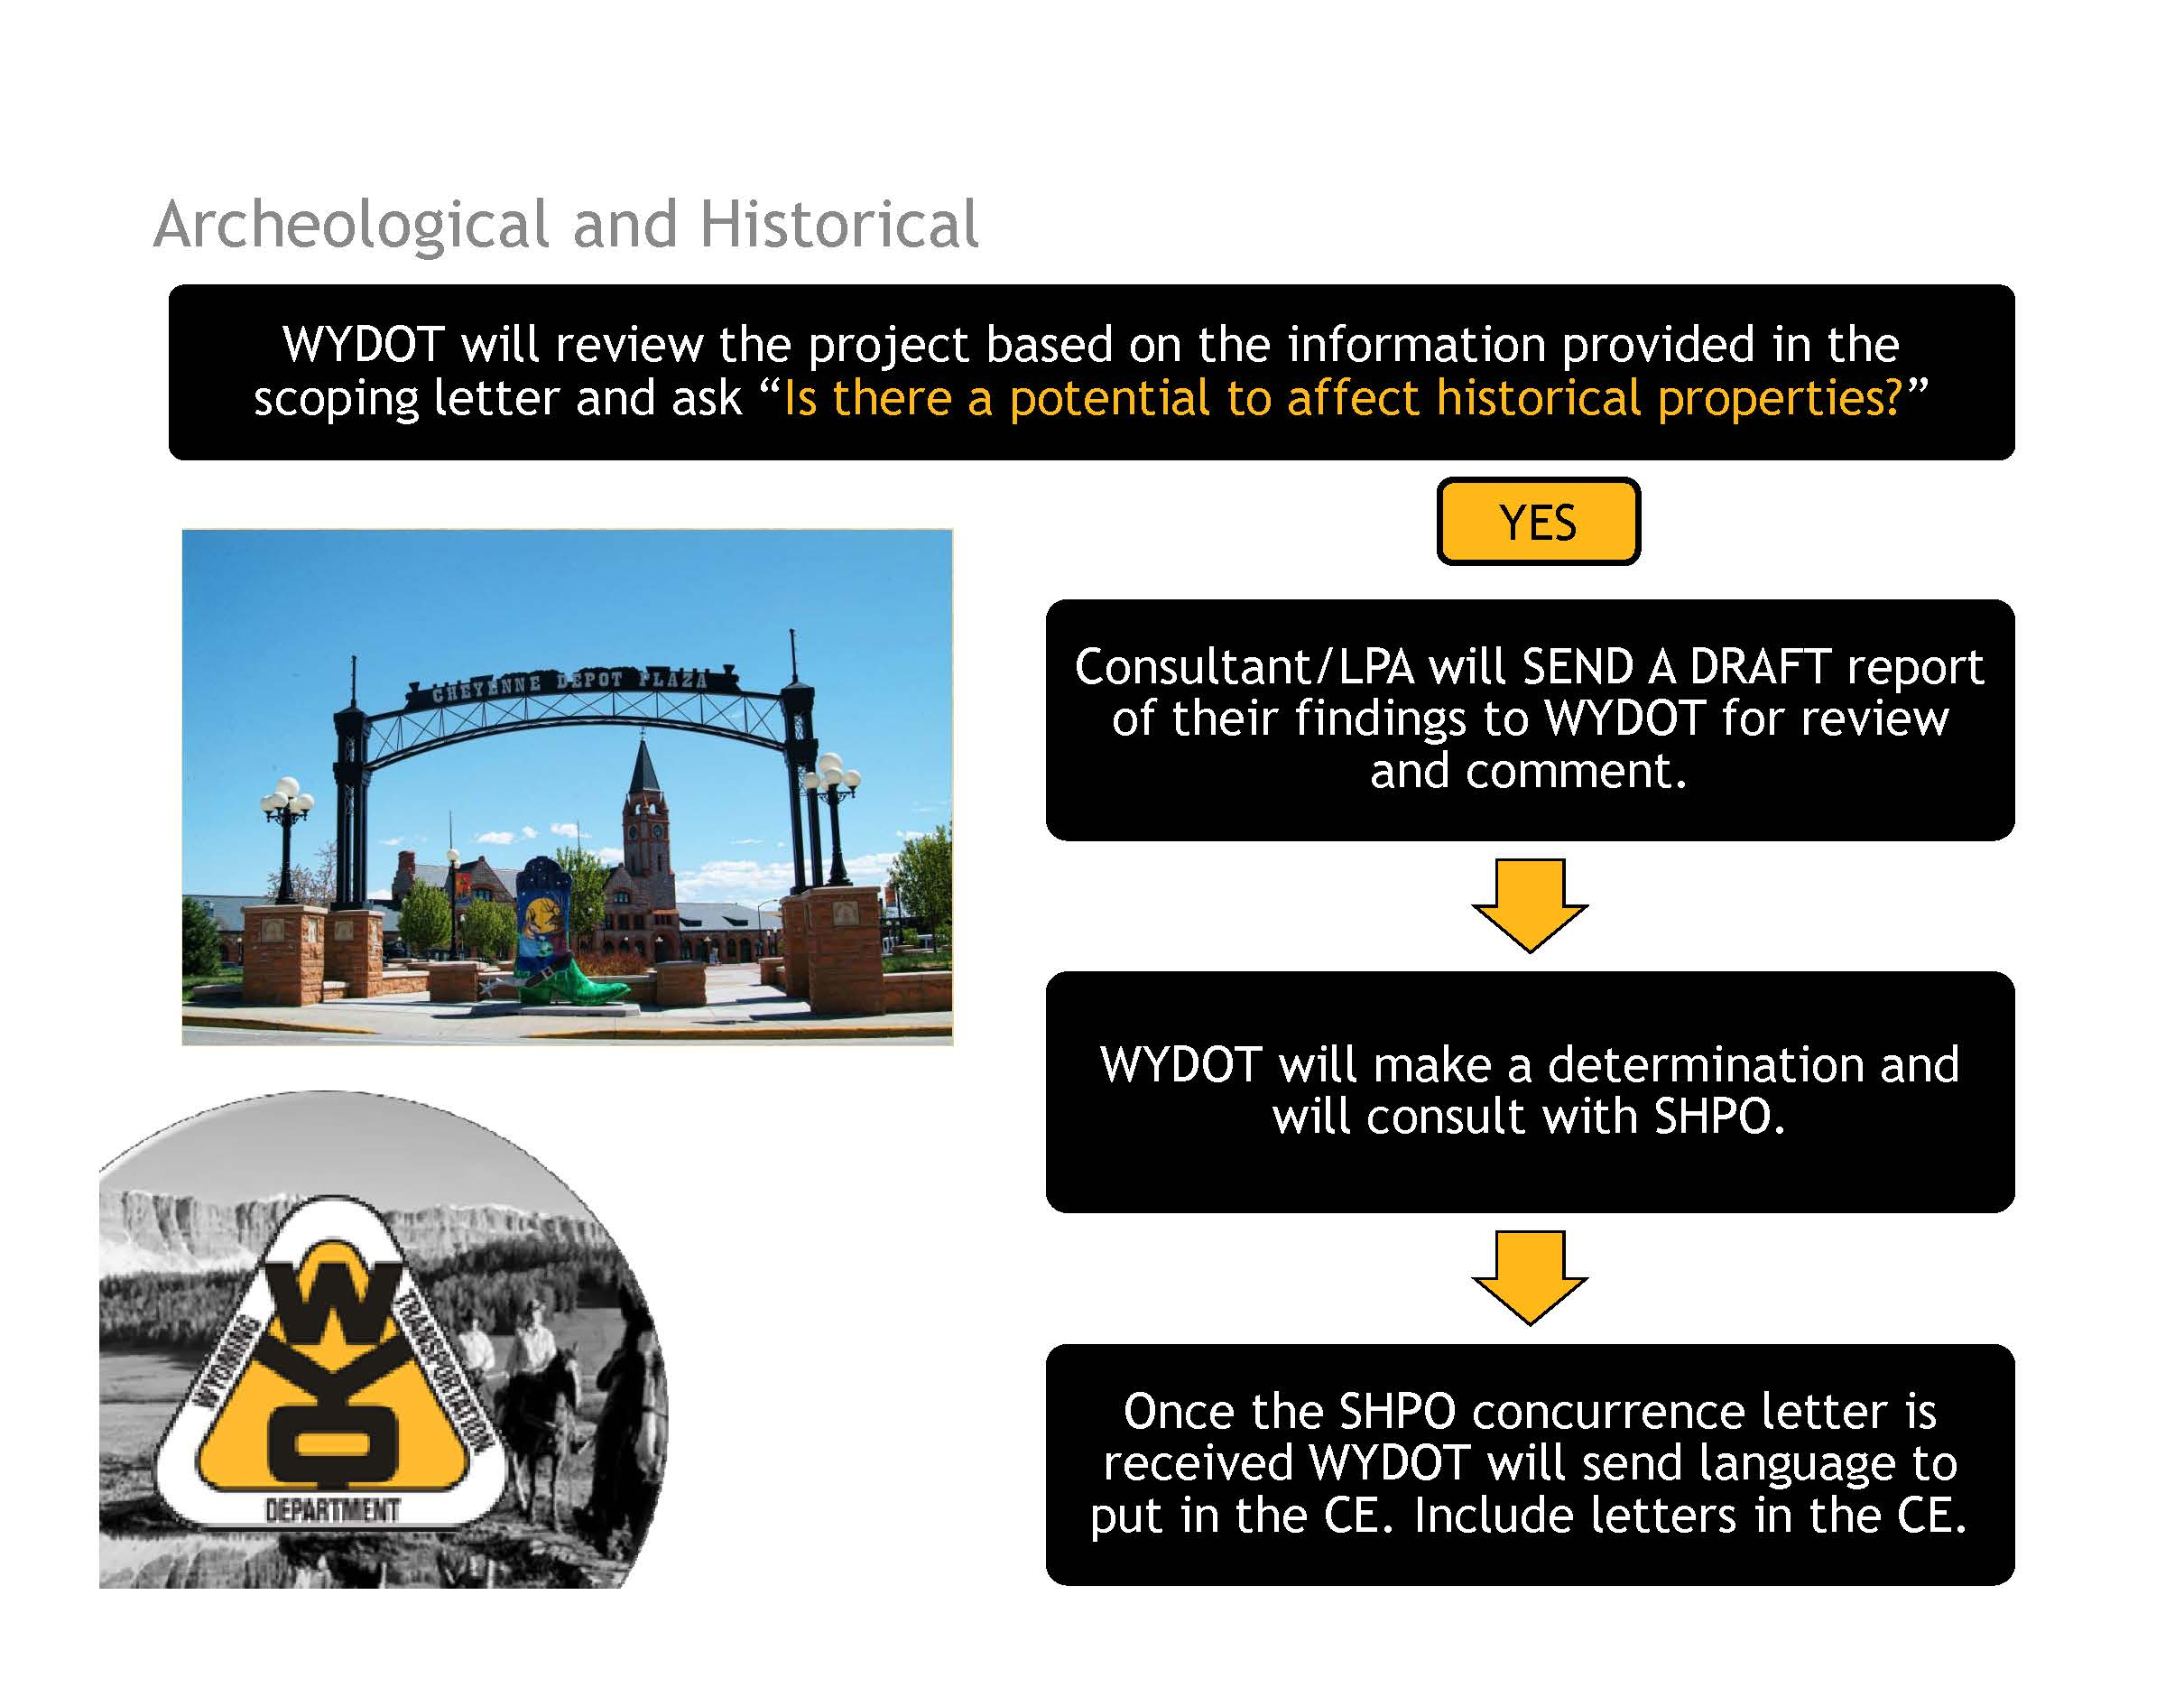

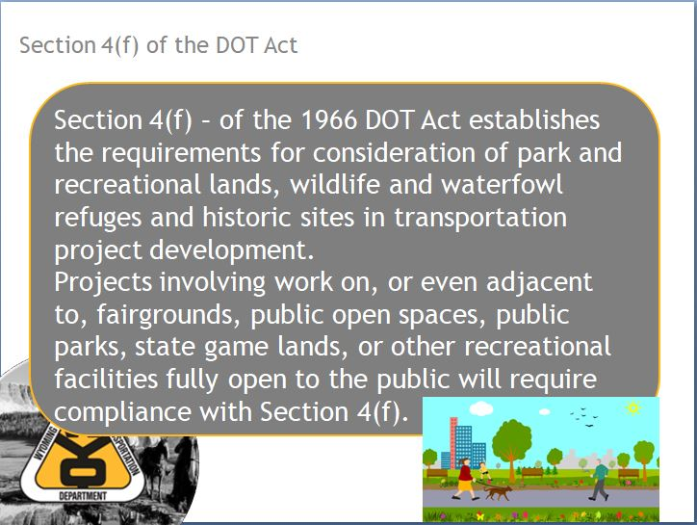

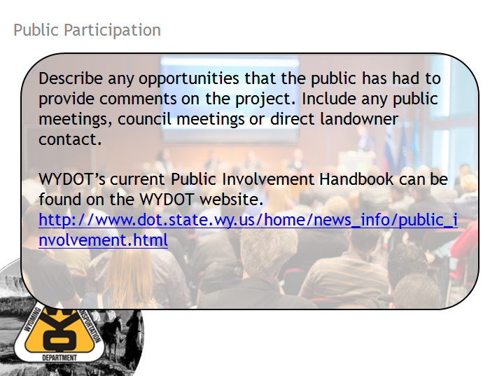

**My Notes:**

**My Notes:**

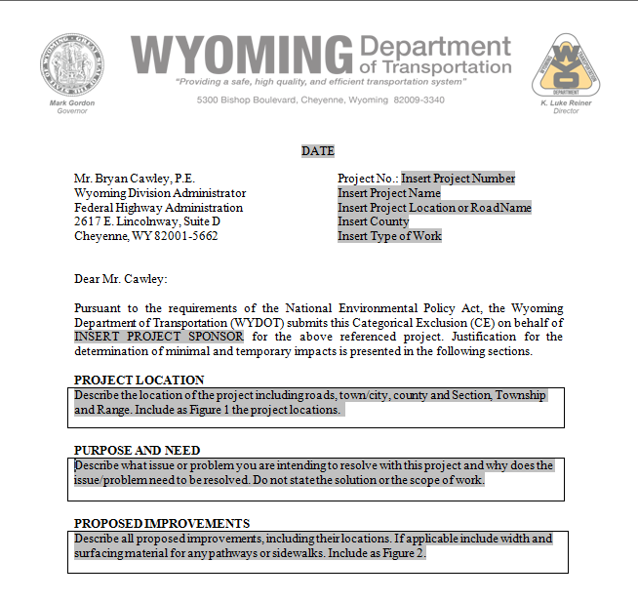

**My Notes:**

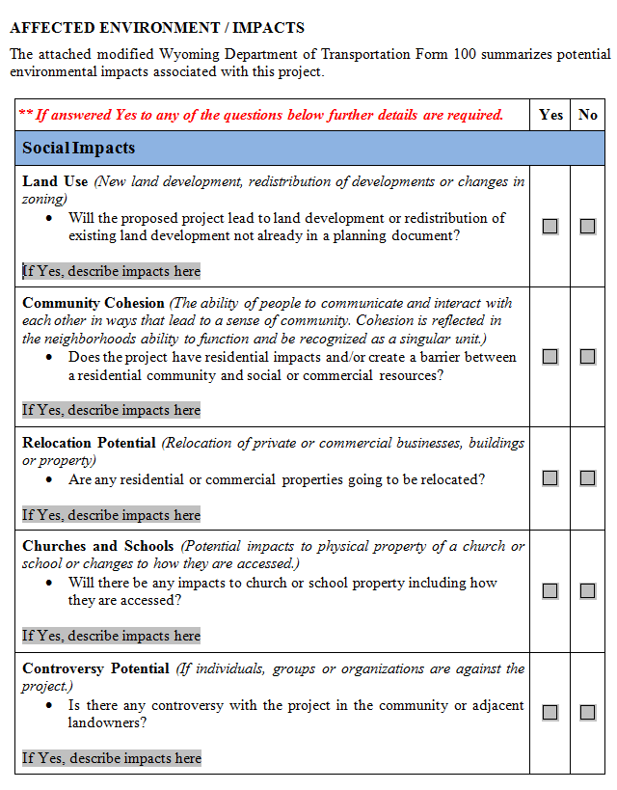

**My Notes:**

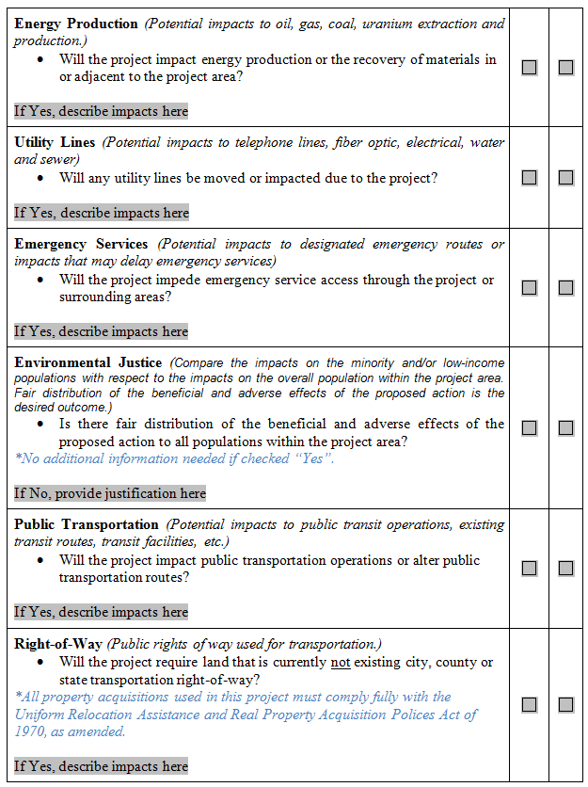

**My Notes:**

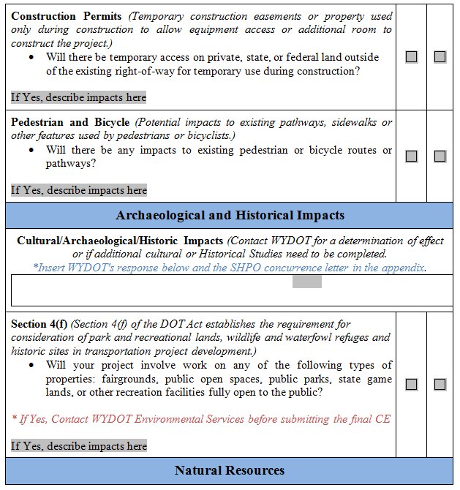

**My Notes:**

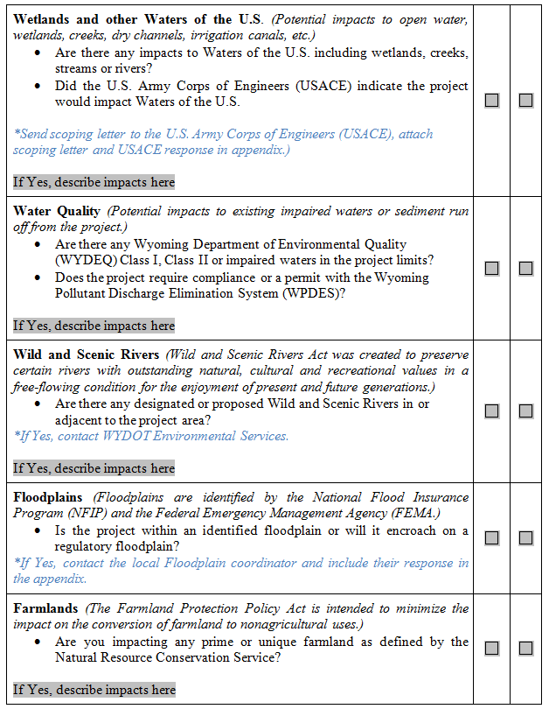

**My Notes:**

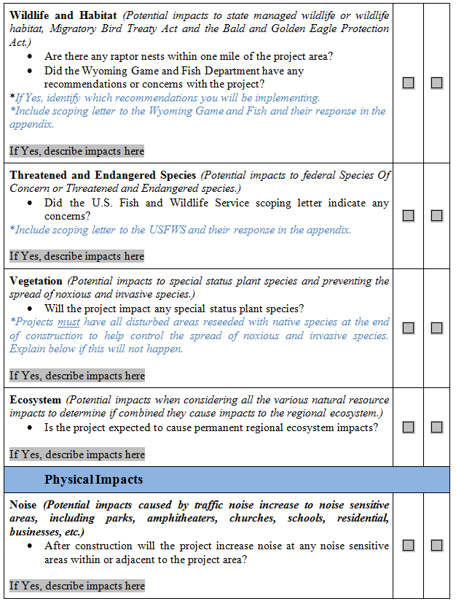

**My Notes:**

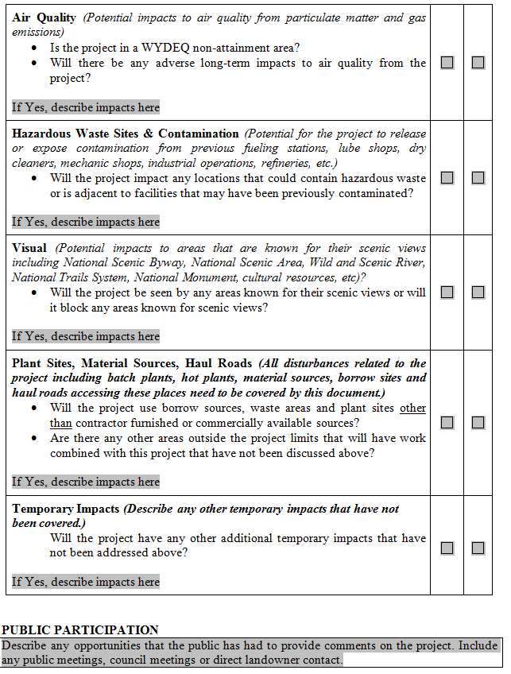

**My Notes:**

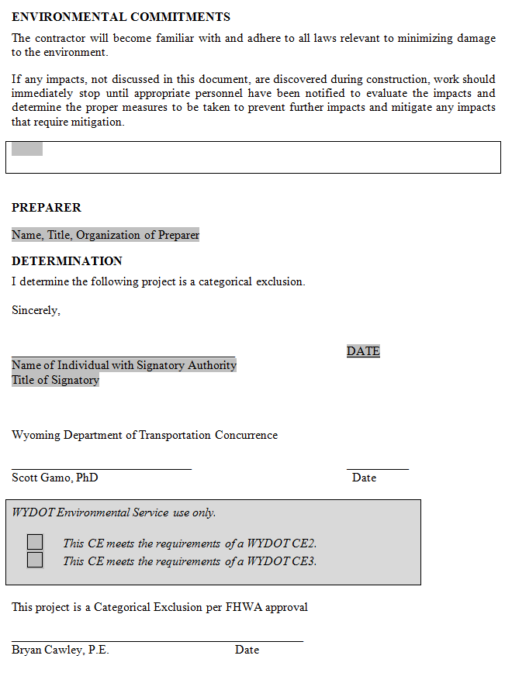

**My Notes:**

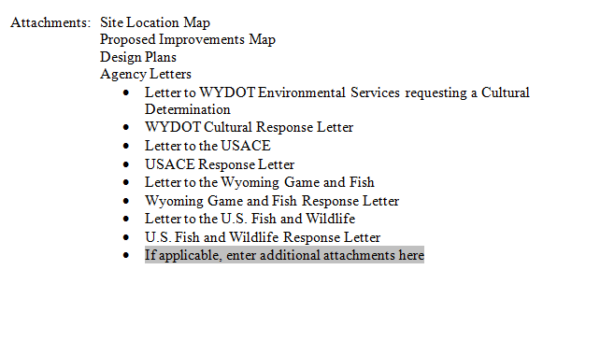

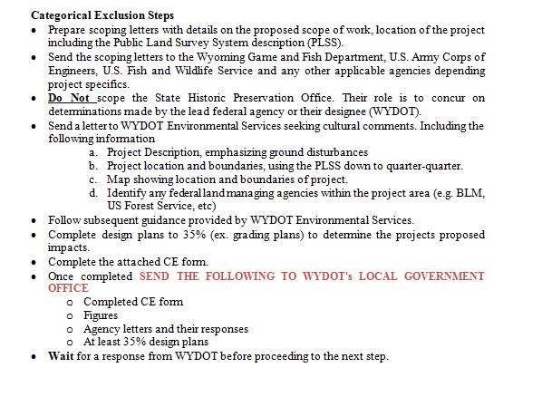

**My Notes:**

**My Notes:**

**Avoid Common Mistakes by Following These Guidelines:**

* Include all reports that are used to support your CE, which can include Aquatic Resources Inventory Report (Wetland Delineation) if you identify wetlands on the project or biological reports.
* Leave out Cultural Reports in the CE (they contain confidential information).
* Include a response from USFWS. The Information Planning and Conservation System (IPAC) on the USFWS website does not replace a response from USFWS.
* Be sure the CE matches cultural and historical language in the letter from SHPO.
* Wait until after the CE has been approved to complete the Final Design Plans.
* Be sure to use the most recent CE template on the website.
* Attach all agency letters – both to and from outside agencies.
* Include all figures needed to thoroughly describe your project.
* Include at least grading or 35% plans for review with the CE.
* Be consistent and forthright in your CE.
* Include a clear and concise project description.
* Be sure that CE and agency response letters match.
* Make sure you send your CE to WYDOT and NOT FHWA.